CSE 581

**Lab 11: Views**

*Do this against YOUR own database.*

**Steps:**

1. Create a view that will display all of the following columns, joining tables as appropriate:
2. Student First Name
3. Student Last Name
4. Course Title

CREATE VIEW StudentCourses AS

SELECT u.FirstName + ' ' + u.LastName as StudentName, c.CourseTitle

FROM Users u, CourseEnrollment ce, Courses c

WHERE u.NTID = ce.StudentId

AND ce.CourseId = c.CourseId;

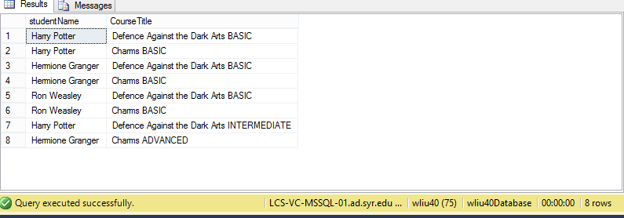

1. Create a view that will display all of the following columns, joining tables as appropriate:
   1. Student First Name
   2. Student Last Name
   3. Course Title
   4. Course Faculty First Name
   5. Course Faculty Last Name
   6. Final Grade (number)

CREATE VIEW [Student Courses Faculty Grade] AS

SELECT u.FirstName + ' ' + u.LastName as StudentName,

c.CourseTitle,u1.FirstName+ ' ' + u1.LastName as FacultyName,

ce.FinalGrade

FROM Users u

INNER JOIN CourseEnrollment ce

ON u.NTID = ce.StudentId

INNER JOIN Courses c

ON ce.CourseId = c.CourseId

INNER JOIN Users u1

ON u1.NTID = c.Faculty

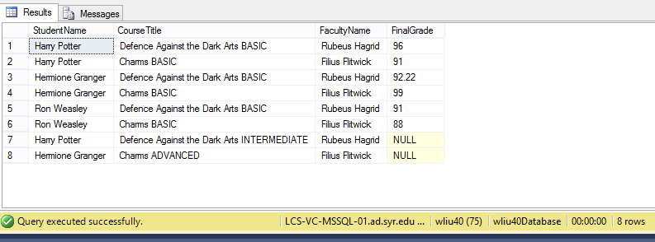

1. Select data from the 2nd view, *for Harry’s classes only*.

SELECT *

FROM [Student Courses Faculty Grade]

WHERE StudentName = 'Harry Potter'

